PROJECT SUMMARY
Project Title
Building High-Quality, Low-Cost Medical Devices Using 3D Printers and Rapid Prototyping Technology

PLAIN LANGUAGE ABSTRACT
Please describe the proposed project using non-technical language emphasizing the research question and importance to health care delivery. Max 1250 characters
The Glia Academic Collaboration is a medical research project whose goal is to develop, validate, certify and disseminate high-quality, low-cost, open-access medical devices that have been approved by Health Canada. These open source devices will be available for wide use in Canada and internationally, especially at low-volume hospitals and low-income communities.
The availability of inexpensive and modifiable medical devices will improve patient care by giving rural and disadvantaged communities better access to important, life-saving, quality medical devices. Devices like this are currently unattainable due to high costs or logistical barriers.
The project philosophy allows for open access to all work, data and procedures, as well as access to software and hardware plans of finished products. These efforts will enable local, national and international hospitals and ministries to build their own high-quality, safe and affordable medical devices. This allows for better supply chain management, reduces repair costs, and minimizes time during which equipment is inoperable. This will result in significant cost savings for clinics, hospitals and ministries of health.
What is the innovation and main question or hypothesis for this proposal? Max 1250 characters
The Glia Academic Collaboration's innovation relies on two pillars: the use of 3D printers and other rapid prototyping technology; and leveraging Open Access and Open Source principles and devices to decrease development costs and disseminate results to stakeholders.
The introduction of these pillars to traditional device development models allows rapid and inexpensive development of critical devices and wide distribution to low-resource or low-availability settings. In addition to lowering the cost of entry, devices can be modified for local conditions. These variants can easily be contributed to publicly available repositories for other centres to evaluate and use.
This model has been proved with a simple medical device (the stethoscope), and is currently being extended to devices such as the pulse oximeter, electrocardiogram, and hemodialysis.
Please describe how this project will influence the health care system or influence patient care. Max 1250 characters
Our project will be influential to small clinics and underserviced hospitals as they will be able to own and maintain high-quality medical devices with decreased cost burden. Our project will aid hospitals and ministries of health in the direct manufacture of this device. The availability of research-validated open source designs will also allow current low-cost manufacturers to re-enter the market with higher quality devices and will exert overall downward pressure on commodity medical device costs. The availability of high quality generic brands will in turn exert pressure on premium brand manufacturers to match or reduce prices. This has been observed in the consumer and pharmaceutical spaces, and there is no barrier to its replication in the medical device space.
In addition, any team that wishes to modify the device for their needs can do so without having to expend time and money to reverse engineer consumer devices, license devices or gain buy-in from manufacturers.
One societal impact of this work is to allow equal-access to a gold-standard medical device for patients in poor or disadvantaged communities.

PROJECT NARRATIVE PROPOSAL
Background, Objectives, Rationale, Significance, and Justify why the project is innovative. Also include an assessment of expected outcomes. Max 8000 characters
Background and Rationale
The high cost of modern medical diagnostic and therapeutic devices renders them inaccessible to solo clinics, junior physicians, students, nurses and other allied professionals. In some low-resource institutions such as in rural clinics and low-income countries, there may be fewer devices than are needed. Sometimes, devices are even completely unavailable. This results in a reduction of the standard of health care compared to richer and more urban institutions. This division impacts populations that are more rural, more poor, more aboriginal and more coloured disproportionately, perpetuating cycles of poverty and disenfranchisement.
The Glia Project uses an open access research, development and distribution model to create high-quality low-cost medical devices that are then clinically validated. This allows off-patent devices to exist as high-quality generic models, which will eventually exert downward pressure on prices for high-quality premium brands.
The stethoscope is a mature proof-of-concept for this model. Stethoscopes are simple instruments that have undergone little innovation in design or fabrication for decades. Despite this, the Littmann Cardiology IV, widely regarded as the field’s gold standard, still costs several hundred dollars. This cost is a barrier to providing comprehensive car.

Modeling off the 1963 Littmann design whose patent expired decades ago, we created a stethoscope that performs on par with the Cardiology III (using a chest wall phantom and analyzing spectral analysis between models) at a cost of $2.83 USD (images and supporting data included in Appendix A). To reduce cost, 3D printers are used to create several parts including the stethoscope head, Y-piece, spring and ear tubes. This device has been validated and is certified by Health Canada as a class I device.
Pulse oximetry is also a vital tool in the rapid and non-invasive assessment of patients, providing a continuous estimate of hemoglobin oxygen saturation in arterial blood. Unfortunately, the costs of these devices are prohibitive and reduce availability in smaller centres, putting patients in danger of easily treatable and preventable conditions. With current rapid prototyping technologies such as 3D printing, it is possible to create a very inexpensive pulse oximeter that meets or exceeds the gold standard.
Objectives
The goal of this project is to develop, validate and certify medical devices such as the pulse oximeter, electrocardiogram, and hemodialysis. These devices will be certified with Health Canada, and then released under the Open Hardware License (OHL), such that hospitals and ministries in rural and impoverished communities would have easy access to these devices.
The project reduces the asymmetry of care by providing physicians and allied professionals – especially those in low-income health systems – with access to high-quality, low-cost medical equipment.
To do this, we will:
- Complete engineering prototypes and make modifications during the project as needed.
- Complete calibration and validation studies of our 3D printed prototypes to the current devices' standards.
- Gain regulatory approval through Health Canada.
- Create partnerships with hospital and ministry of health biomedical departments to manufacture and distribute devices to nurses, paramedics, medical students, junior doctors and other allied professionals.
- Publish all specifications, production files and data in a way that is unencumbered by patents or other restrictions on reproduction (Open Source).

Significance
This project will impact the availability and quality of pulse oximeters in Ontario, especially in solo clinics, rural hospitals and remote outposts. It will also encourage the repair of devices onsite, reducing equipment downtime and repair costs.
Glia's stethoscope has already made a significant impact, being inducted into the Canada Science and Technology Museum and being covered by numerous news publications. It has also received interest from Canadian medical students and allied professionals and is being distributed in London, Ontario followed by other Ontario centres with limited access to medical devices. There are even international hospitals in low-resource settings that are self-sufficient producers of these stethoscopes using recycled plastic. Several staff in the Division of Emergency Medicine already use these stethoscopes.
The Glia Project team produced approximately 200 stethoscopes and distributed them to Western University staff, students and residents. Our team is producing another 1000 stethoscopes for the remainder of the Division of Emergency Medicine. The final design is openly available for production by other medical schools and hospitals.
Replicating this success with pulse oximeters will lead to the wide availability of devices. The availability of specifications for generic manufacturers to manufacture devices and the subsequent downward price pressure on premium brand manufacturers will increase the standard of care for all patients in Ontario. It will also allow LHINs to save costs while maintaining equivalent quality of care.

Innovation
The Glia Project innovates in several major domains: The use of rapid prototyping technology such as 3D printing; The use of Open Source Hardware and Software methodologies; The Open Access approach to distribution of devices and design files.
Rapid prototyping technologies such as 3D printing are common in the research and development stages of medical device creation. However, no market devices exist that are mass-produced using these technologies. Our team has made significant strides in eliminating problems associated with the use of 3D printing for mass manufacture, and will continue to develop this versatile and adaptable technology for mass manufacturing. Our team is at the leading edge of this technology.
Open Source Software development started under the GNU Public License in the 1980's. In the past decade, this methodology has been applied to a nascent DIY electronics movement. As yet, there are few makers of Open Source Hardware, and none that make pulse oximeters that can be safely and legally used by health care providers. This project combines the techniques of Open Source Hardware and Software development with the highly regulated field of medical devices to create a brand new space in biomedical engineering.
Open Access publication of journal articles has been popular for at least the past decade since the inception of the Public Library of Science (PLoS). However, the label seldom encompasses what the Glia Project has released: Complete bill of materials, schematics, validation data and aids to recreate and test devices. To the best of our knowledge, no certified medical device has ever done this.
The Glia Project's innovations will allow medical institutions and medical schools in Ontario to manufacture and repair their own devices for medical students and allied professionals as needed. Each hospital or medical school could create an inexpensive but state-of-the-art facility where production, distribution and further innovation can take place. Any medical device the project develops subsequently can join the repository of devices available for production by these centres.

Assessment of expected outcomes
Our outcome measures are as follows:
- Number of total deployed pulse oximeters
- Number of participating medical schools
- Number of participating hospitals
- Number of participating health care centres (non-hospital)
- Calibration study of pulse oximeter (yes/no)
- Validation of pulse oximeter (yes/no)
- Health Canada certification of pulse oximeter (yes/no)

References
1. Walker, I. & Wilson, I. Anaesthesia in developing countries - a risk for patients. Lancet 968–969 (2009).
2. Haynes, A., Weiser, T. & Berry, W. A surgical safety checklist to reduce morbidity and mortality in a global population. New Eng J Med 491–499 (2009).
3. Duke, T., Graham, S. & Cherian, M. Oxygen is an essential medicine: a call for international action. Int J Tuberc Lung Dis 1362–1368 (2010).
4. Ashraf, H., Jobayer, M. & Alam, N. Treatment of childhood pneumonia in developing countries. (2010).
5. Kwizera, A. & Dunser, M. A Global Perspective on Acute Respiratory Distress Syndrome and the Truth about Hypoxia in Resource-limited Settings. Am. J. Respir. Crit. Care Med. 5–7 (2016).
6. WHO. Global Pulse Oximetry Project. (2008).
7. Funk, L., Weiser, T. & Berry, W. Global operating theatre distribution and pulse oximetry supply: an estimation from reported data. Lancet 1055–1061 (2010).
8. Bagchi, S. Telemedicine in rural India. PLoS Med e82 (2006).
9. Varma, N. Role of the surface electrocardiogram in developing countries. J. Electrocardiol. 612–614 (2010).
10. Silva, I. & Moody, G. An Open-source Toolbox for Analysing and Processing PhysioNet Databases in MATLAB and Octave. J. Open Res. Softw. 2, (2014).
11. Costa, M., Moody, G., Henry, I. & Goldberger, A. L. PhysioNet: an NIH research resource for complex signals. J. Electrocardiol. 36, 139–144 (2003).
Appendix A
Item | Dimensions | Cost (USD)
Stethoscope head | 44.30mm x 62.45mm x 17.80mm | $0.206
Stethoscope Y piece | 70.89mm x 29.94mm x 9.00mm | $0.09
Stethoscope ear tube | 170.79mm x 83.62mm x 5.80mm | $0.07
Stethoscope ring | r = 21mm, h = 7mm | $0.012
Stethoscope spring | 91.25mm x 111.62mm x 15.05mm | $0.032
Silicone tubing | 40 cm – 12mm OD, 8mm ID / 2x 9 cm – 6mm OD, 4 mm ID | $1.93
Diaphragm | r = 20mm | $0.06
Ear plugs with mold | n/a | $0.43
Total |  | $2.83
Table 1. Bill of materials for the Glia model stethoscope (100% infill)
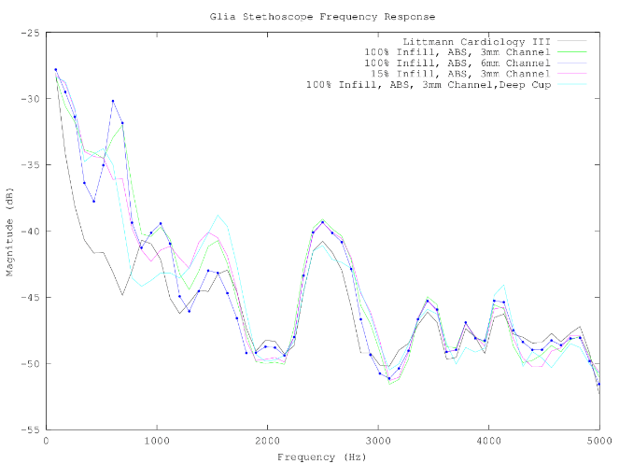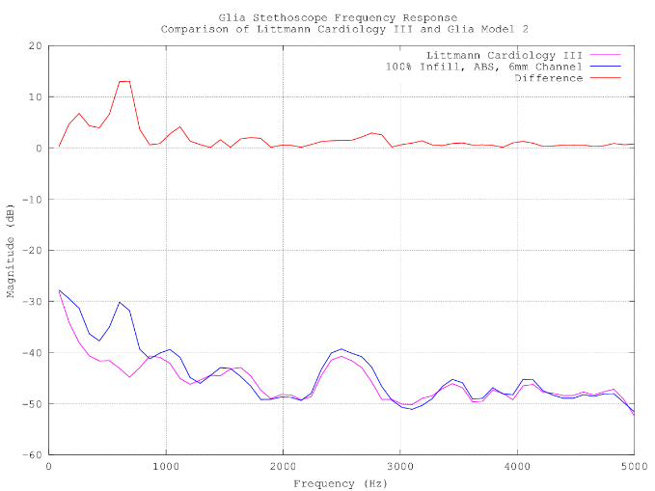
Calibration and comparison of 3D printed Glia model stethoscopes to the gold standard Littmann Cardiology III. Stethoscope output responses were measured using the equipment setup described in the methods. Each stethoscope model recorded input sound at multiple frequencies and the change in amplitude between input and recorded sound was documented for each stethoscope. Further comparison between the Glia Model 2 and the gold standard Littmann Cardiology III is shown in with the absolute Δmagnitude plotted above.
Appendix B
Item | Cost (CAD)
Infrared Emitter 940nm | 0.38
640nm LED | 0.77
25x Header and Wire House Connector | 4.00
Light To Frequency & Light To Voltage Converter | 2.06
FFC & FPC Connectors | 1.44
ARM Micrrocontrollers | 1.96
Fixed Inductors WE-TPC 2811 | 2.07
Speakers & Transducers | 2.71
Voltage Regulators | 0.90
2x Tactile Switches | 0.67
3x Thick Film Resistor 1/20watt 1Mohms | 1.13
Thick Film Resistor 1/10watt 590Kohms | 0.15
Thick Film Resistor 1/10watt 2.0Kohms | 0.15
LDO Voltage Regulator | 0.58
4x Multilayer Ceramic Capacitors – MLCC SMD/SMT 0603 0.1uF 16V | 0.58
2x Multilayer Ceramic Capacitors MLCC – SMD/SMT 6.3V 10uF | 0.55
2x Multilayer Ceramic Capacitors MLCC – SMD/SMT 0603 4.7uF 6.3V | 0.32
9x Multilayer Ceramic Capacitors MLCC – SMD/SMT 0603 1uF 10V | 1.31
LCD w/Touch Panel | 4.7
Total | 26.43
Table 2. Bill of Materials for the Glia Pulse Oximeter

